11th of September 2020

Oleg GORB, Vice-rector to scientific and pedagogical work presented the main aspects of the project. He stressed that one of the project objectives is the visualization of stakeholders’ capacities to the cooperation and encouraging them to become a part of clusters. He informed the meeting participants that Poltava state agrarian academy will work on the creation of the expert center specialized on milk production and processing with the accent on the development of local products. The partner of the Academy is a farmer enterprise “Dobro-Kraft” that will be responsible for the practical part of the project implementation. In the framework of the project some research activities will be implemented and a new working profession - cheese maker will be created as an additional initiative.

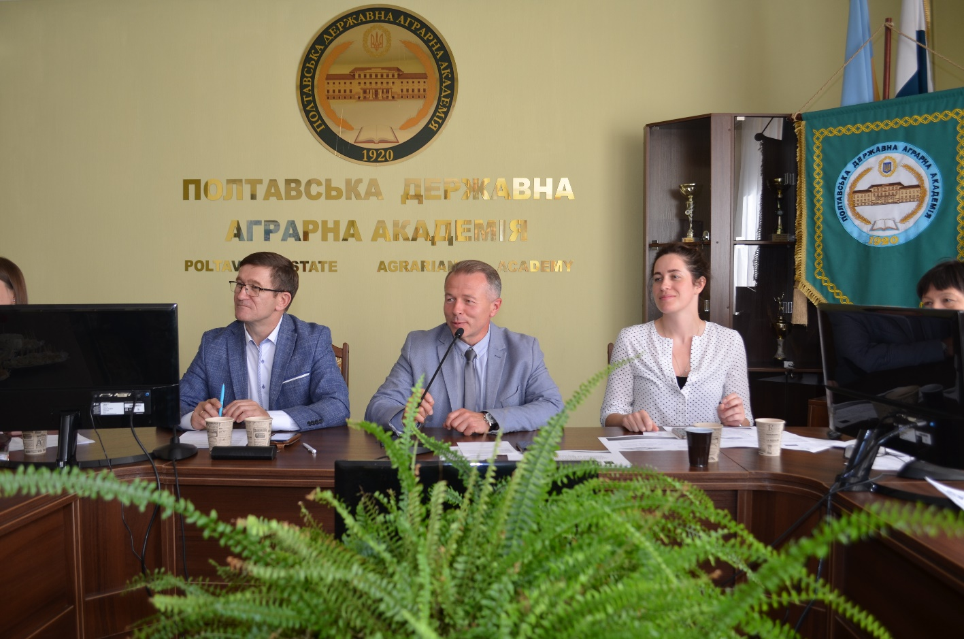

The representatives of the Scientific and methodological center of higher and vocational education of Ukraine participated in the event on-line.

Tetiana ISHCHENKO, head of the Center greeted the participants of the meeting. She noticed the importance of the support of the project by the Academy administration and the local authorities. Clusters are very popular form of the cooperation in the Europe and we are happy to see that they began to develop in Ukraine.

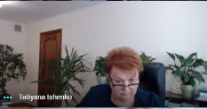

Sergii FROLOV, head of the Department of Agro-industrial Complex of Poltava State regional administration mentioned several positive examples of the development of clusters initiatives in the region mainly in the area of tourism. Due to these initiatives important investments were attracted for the development of the local infrastructure, 50 new job opportunities were created. Now, the Administration is working on the development of the project of the development of agro-industrial complex in the region, so some financing for clusters development should be attributed.

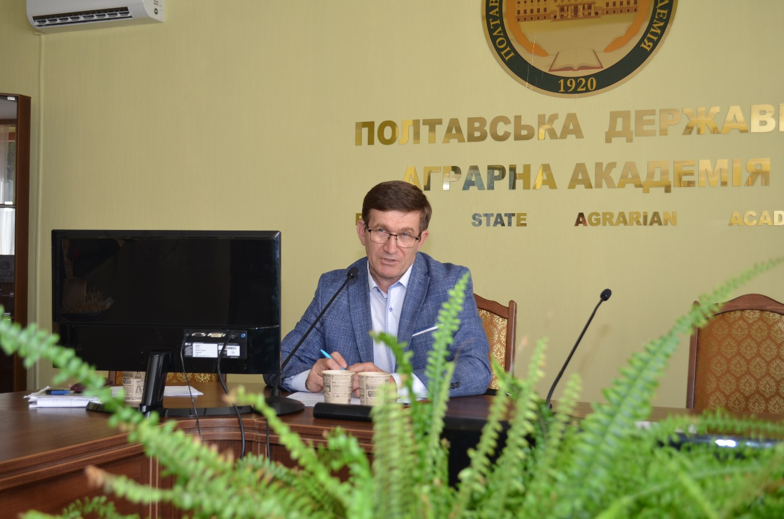

Liudmyla STEPURA (HPHE) presented the project activities foreseen for three years such as: training sessions, study visits, students mobility, promotion of clusters initiatives at local level, development of new modules, creation of expertise centers, development and implementation of pilot research projects within the centers.

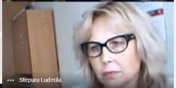

Tetiana KODAK, associate professor of the department of food technology of PSAA presented the key aspects of the faculty activities within the project: creation of the scientific base for the development of milk production and cheese making in the region, creation of the pre-conditions for the development of the model-cluster “Cheeses of Poltava region”, carrying out the survey of consumers behavior as for milk products, development of new modules at the faculty, an active involvement of students in these activities.

Oksana KRAVCHENKO, representative of «Dobro Kraft» farm spoke about the role of small farms in the development of clusters for regional economic development in Poltava region. She presented the farm that has 20 hectares of the land and 50 heads of goats, is specialized on the closed production cycle. In the framework of the project the farm will serve a practical base for teachers and students, will participate in the creation of the pre-conditions for the development of the model-cluster “Cheeses of Poltava region”

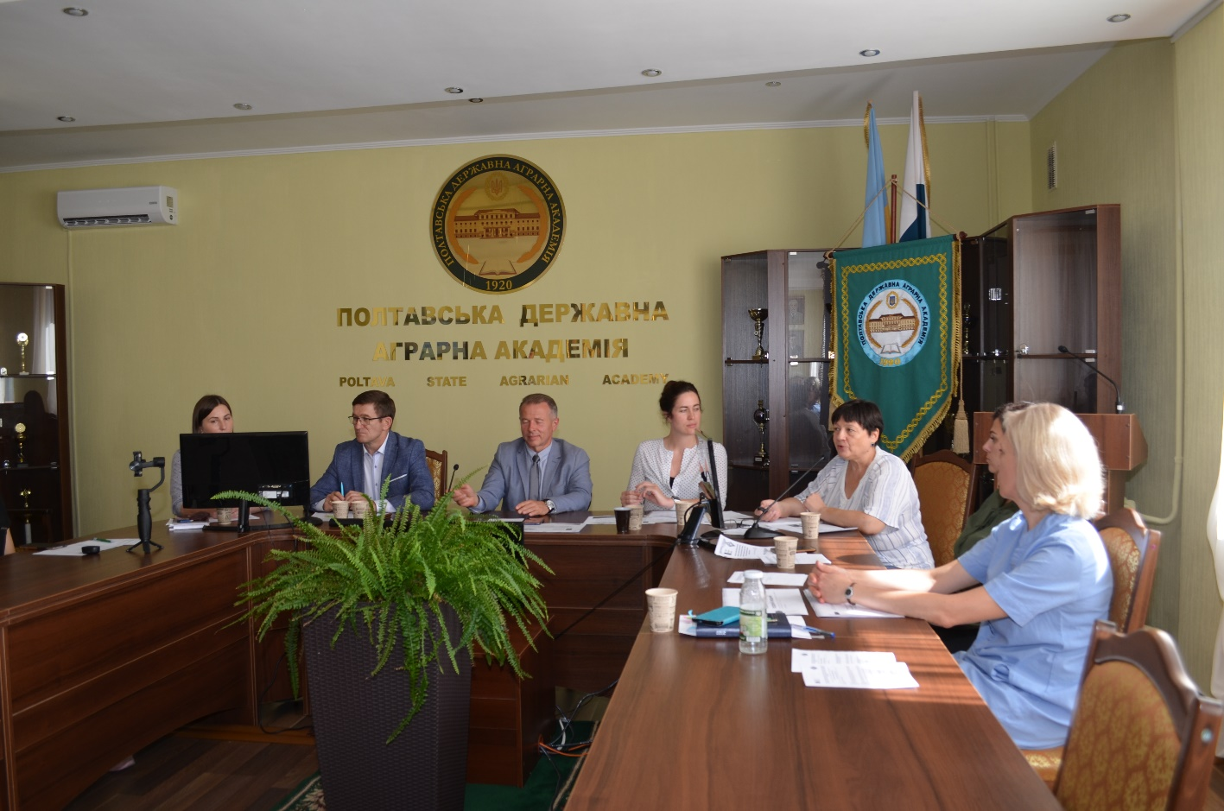

Tetiana DIADYCHKO, head of private enterprise «Koza-chka» as a representative of stakeholders spoke about the impact of the project on the development of the network of local milk and dairy products producers. She confirmed her willing to cooperate with the project and expressed her hope that other producers will join this initiative.

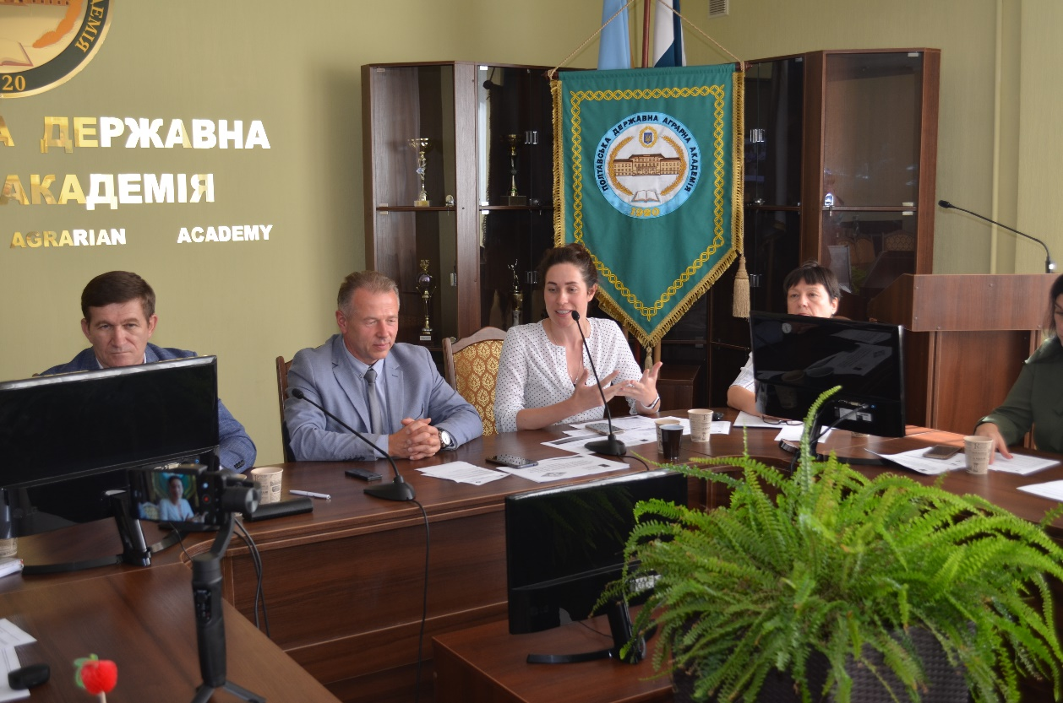

Yuliia VAKULENKO, head of the Educational and scientific institute of information and innovation educational technologies presented the prospects for implementing the opportunities of cheese maker profession in Poltava State Agrarian Academy. It was not foreseen in the project proposal but this initiative was accepted as a peer activity. She presented already the model of the curriculum for this new profession and noticed that it will give additional possibilities for the employment of the faculty graduators.

At the end the meeting the cheese makers presented some samples of their products.

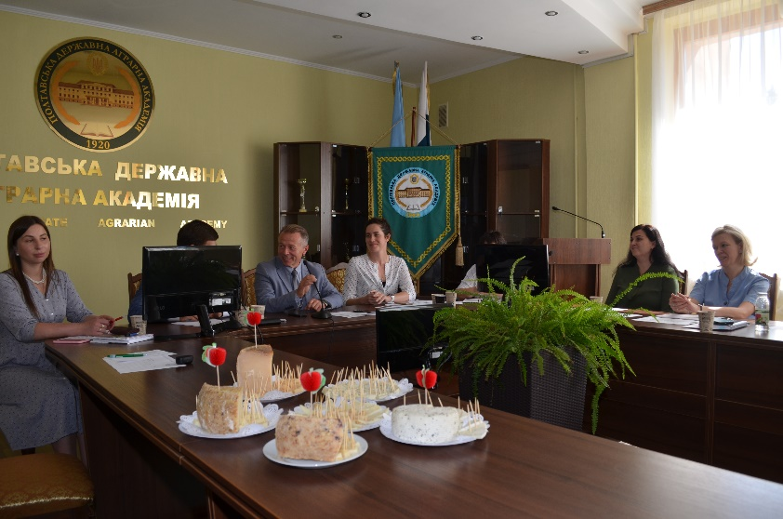 | 